

**Informatics Practices Project 2021 – 2022**

**Topic: Covinfo Application**

**Programmer : Sandeep Santha Kumar**

**Project Mentor : Ms.Swathi Rajesh**

**Class : XII A**

**Hall Ticket No :20616725**

***Bowenpally, Secunderabad***

**Certificate**

*This is to certify that* ***Master/Miss*** *.............................................................., student of Class* ***XII ……,*** *during the academic year 2021– 2022,**has completed his /her “****Informatics Practices Project Work****” under my supervision. He/She has taken keen interest and has shown utmost sincerity and completed the project work upto my satisfaction in Informatics Practices.*

______________________________ ___________________________

***(Signature of PGT – Informatics Practices) (Signature of External Examiner)***

*___________________________*

***(Signature of Principal)***

***Date:* *School Stamp***

***STUDENT NAME: EXAM NO :***

***ACKNOWLEDGEMENT***

I acknowledge with thanks the support and guidance offered to me by my teacher **Ms. Swathi Rajesh** during the academics year **2021 – 2022** to complete my Project in **Informatics Practices**. Without her support and guidance it would have not been possible to complete my project work in the lab.

I am also grateful to the staff members of the school in providing me timely assistance in completing the project work. I thank them for their consistent support and guidance.

**Date: _____________________**

**Signature of Student**

________________________________

**(Signature of PGT – Informatics Practices)**

**Hardware and Software Requirements**

Hardware Requirements:

Main memory:4GB

Hard disk:400 GB

Processor:Intel Core I3

Software Requirements:

Platform:WIndows 10

Programming Language:Python

Back end: CSV files

Google docs

**INDEX**

**S.No Topic Page Numbers**

1. Introduction

2.Technology used

a) Python

b) Pandas

c)Data Frame

d)CSV file

e)Data Visualization and Matplotlib

3. Coding and Implementation

4. CSV files

5. Conclusion

6. Bibliography

**Introduction**

It has been a couple of years since we’ve been in the current situation, and still the cases are increasing. It is important for the government to keep track of active and recovered cases in each state, in order to ensure safety of the citizens.

**Covinfo** app gives information about:

1. Active and recovered cases in 5 states(Tamil Nadu, Maharashtra, Telangana,West Bengal,Haryana).
2. Number of vaccinated and unvaccinated people in each state

All the data is represented in the form of graphs using python library

**matplotlib** and the data is stored in the form of a **CSV file** (comma separated value files), and is imported to python using pd.read_csv.

**We used line graph, bar graph and pie chart** to represent the data which makes it easy to understand the hike and depression in the number of active and recovered cases over a span of 10 months. We have also used Tkinter to make the covinfo app GUI based.

Team members are ***Sandeep Santha Kumar, Vamsi Krishna, Faiz Ahmed.***

**Technology Used**

**Python:**

Python programming language was developed by Guido Van Rossum in February 1991.

Python is an easy-to-learn yet powerful object oriented programming language.

**Pandas:**

Pandas is the most popular library in the *scientific Python ecosystem* for doing data analysis, Pandas is capable of many tasks including:

* It can read or write in many different data formats (integer, float, double, etc.).
* It can calculate in all the possible ways data is organized i.e., across rows and down columns,
* It can easily select subsets of data from bulky data sets and even combine multiple datasets together.
* It has functionality to find and fill missing data.
* It allows you to apply operations to independent groups within the data.
* It supports reshaping of data into different forms.
* It supports advanced time-series functionality (*Time series forecasting is the use of a model to predict future values based on previously observed values*.)
* It supports visualization by integrating matplotlib and seaborn etc. libraries.

**DataFrame:**

A DataFrame is a Pandas structure, which stores data in two-dimensional way. It is actually a two-dimensional (tabular and spreadsheet like) labeled array, which is actually an ordered collection of columns where columns may store different types of data, e.g., numeric or string or floating point or Boolean type etc.

Major characteristics of a DataFrame are :

* It has two indexes or we can say that two axes - a row index (axis = 0) and a column index (axis = 1).
* Conceptually it is like a spreadsheet where each value is

identifiable with the combination of row index and column index. The row index is known as index in general and the column index is called the column-name.

* The indexes can be of numbers or letters or strings.
* There is no condition of having all data of same type across columns; its columns can have data of different types.
* DataFrames are value-mutable (its values can be easily changed)
* DataFrames are size-mutable (rows/columns can be easily added or deleted)

**CSV File:**

Refers to the tabular data saved as plaintext where data values are separated by commas.

The CSV format is popular as it offers following advantages :

* A simple, compact and ubiquitous format for data storage.
* A common format for data interchange.
* It can be opened in popular spreadsheet packages like MS-Excel, Calc etc.
* Nearly all spreadsheets and databases support import /export to csv format.

Python's Pandas library offers two functions read_csv() and to_csv( ) that help you bring data from a CSV file into a dataframe and write a data frame’s data to a CSV file.

**Data Visualization and matplotlib:**

Data Visualization basically refers to the graphical and visual representation of information and data using visual elements like charts, graphs, and maps, etc.

Data Visualization is immensely useful in decision making unveils patterns, trends, outliners, correlations etc. in the data helping decision-makers understand the meaning of data to drive decisions.

The matplotlib is a Python library that provides many interfaces and functionalities for 2D graphics. matplotlib is a high quality plotting library of python that provides both, a very quick way to visualize data from Python and publication-quality figures in many formats.

The matplotlib library offers many different named collections of methods; PyPlot is one of such interfaces, a collection of methods within matplotlib which allows us to construct 2D plots easily and interactively.

**Tkinter:**

Tkinter is the standard GUI library for Python. Python when combined with Tkinter provides a fast and easy way to create GUI applications. Tkinter provides a powerful object-oriented interface to the Tk GUI toolkit.

Creating a GUI application using Tkinter is an easy task. All you need to do is perform the following steps −

* Import the *Tkinter* module.
* Create the GUI application main window.
* Add one or more of the above-mentioned widgets to the GUI application.
* Enter the main event loop to take action against each event triggered by the user.

**Coding and Implementation**

1. Importing all the libraries and csv files required

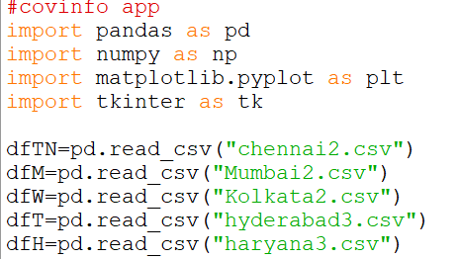

2. Welcome phrase

Output Code





3.Tkinter

Output

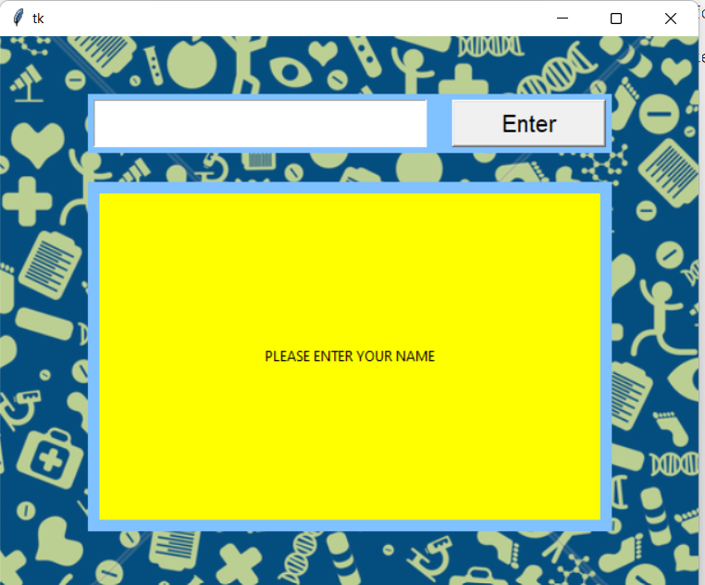

Code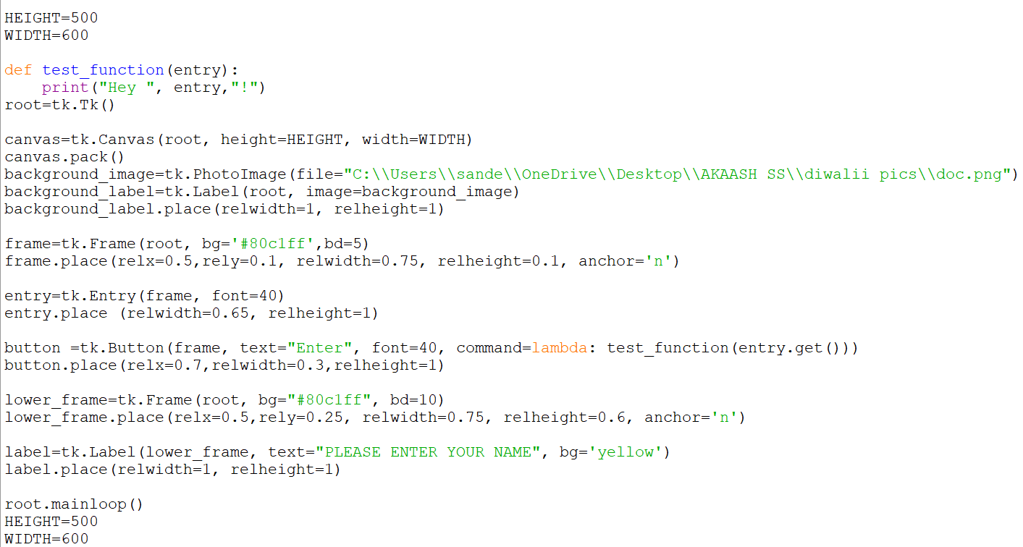

Output

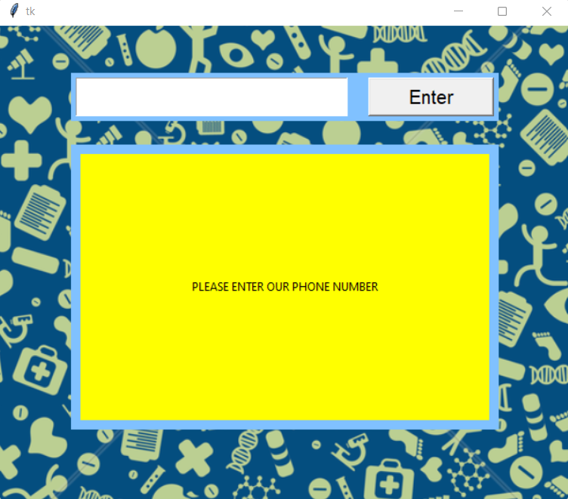

Code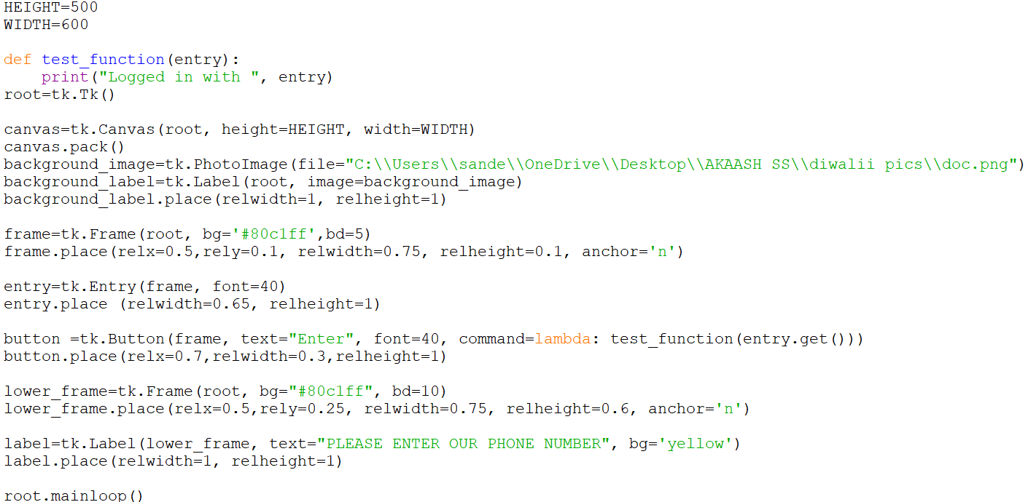

4. Selecting the state

Output

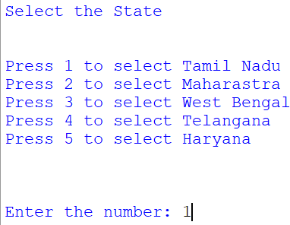

Code

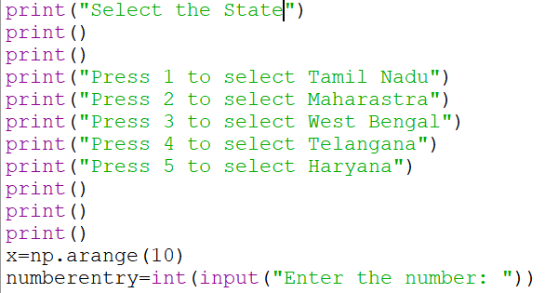

5.Information about the Selected State(For eg: Tamil Nadu)

Output

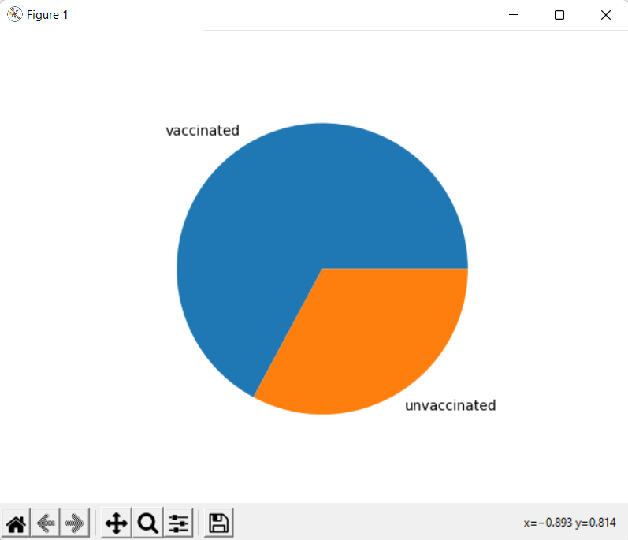

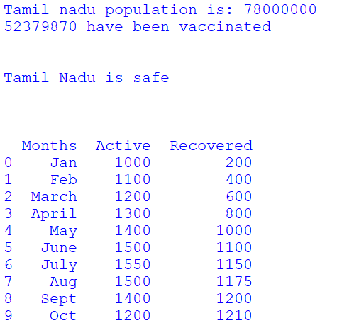

Code

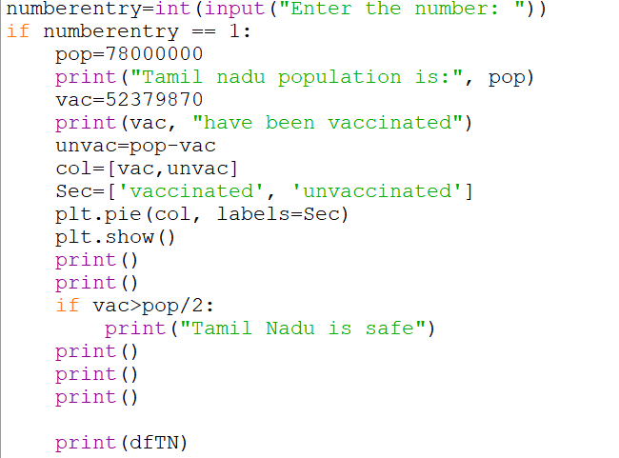

6. Selecting a Function

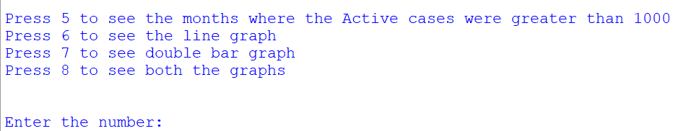

If 5:

Output

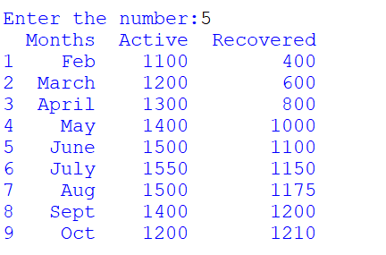

Code

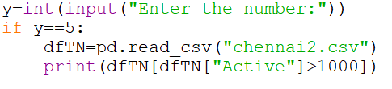

If 6:

Output

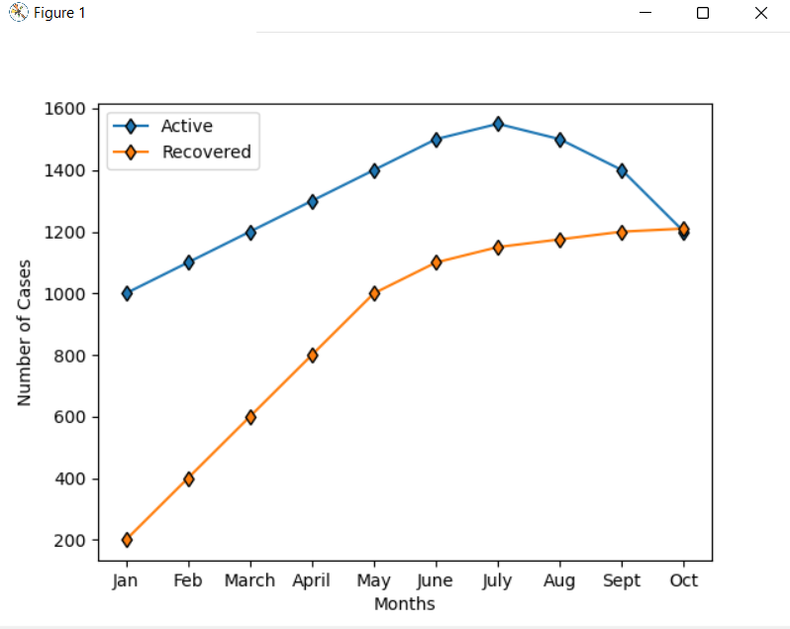

Code



If 7:

Output

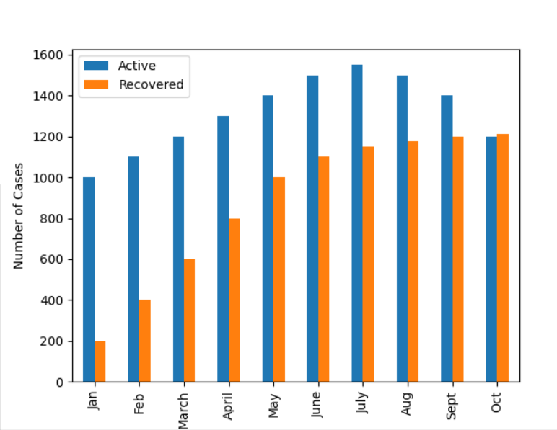

Code

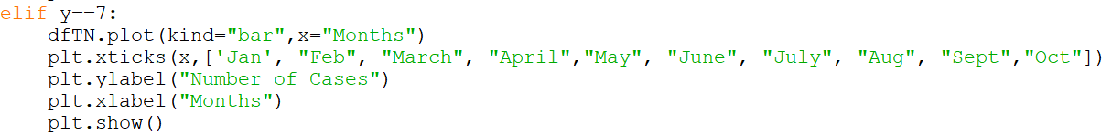

If 8:

Output





Code

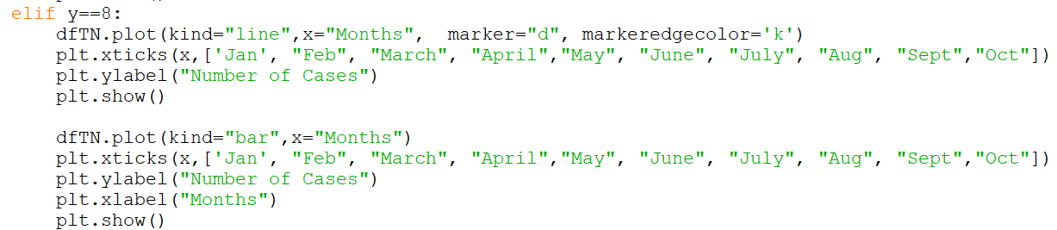

Else:

Output

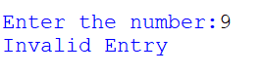

Code

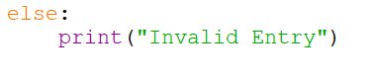

7. Conclusion of the program

Output



Code



**CSV FILES**

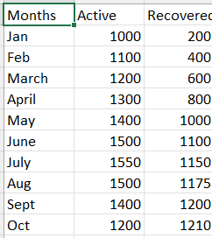 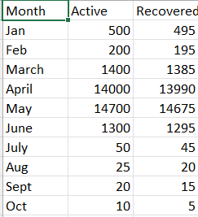

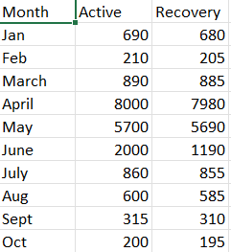 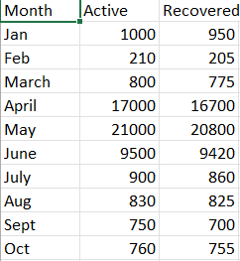

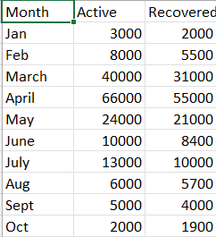

**CONCLUSION**

* With the cases increasing at a rapid rate, it becomes very important to keep a track of active and recovered cases in each state.
* This program helps in doing the same for 5 states.
* People can know the situation in their state and take precautionary measures to stay safe.

**BIBLIOGRAPHY**

1. For the data on Active and Recovered cases:

<https://www.mygov.in/corona-data/covid19-statewise-status/>

2. For Tkinter tutorial:

<https://www.tutorialspoint.com/python/python_gui_programming.htm>